ASSIGNMENT-3
Basic and conditional select statement on employee database
1. Display all the employee’s information whose job is Clerk.
A: SELECT * FROM emp WHERE job = 'CLERK';
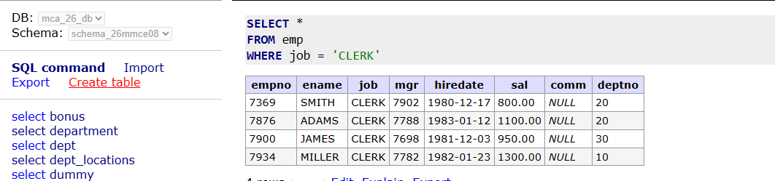
2. Display all the employee’s information whose employee number is 7788.
A: SELECT * FROM emp WHERE empno=7788;
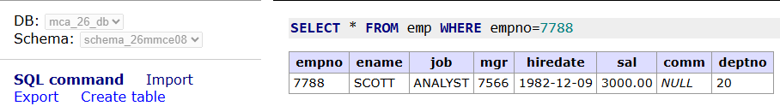
3. Display all the employee’s information whose commission is greater than his salary.
A: SELECT * FROM emp WHERE comm > sal;
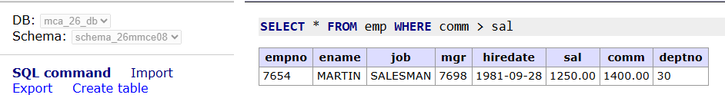
4. Display all the employee’s information those who are drawing a salary between1000and 2700.
A: SELECT * FROM emp WHERE sal BETWEEN 1000 AND 2700;
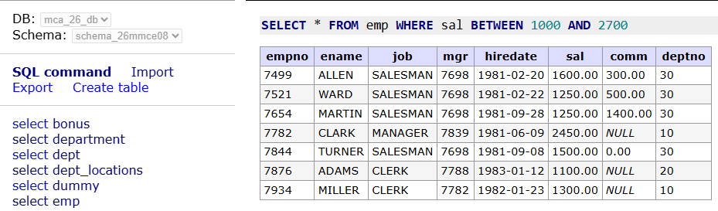
5. Display all the employee’s information whose employee number falls within acertainlist.
A: SELECT * FROM emp WHERE empno IN (7369, 7566, 7788, 7902);
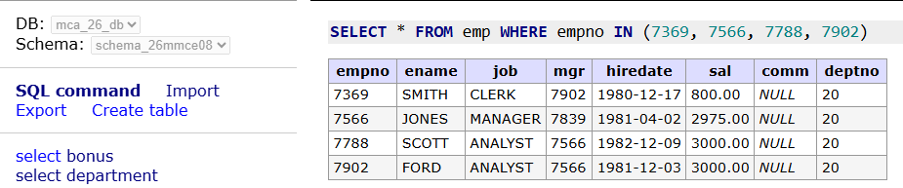
6. Display all the employee’s information those whose commission is not known.
7. Display all the employee’s information whose employee name starts withanalphabet 'S'.
8. Display all the employee’s information whose employee name's third alphabet is'O'.
9. Display all the employee’s information whose employee name is of four charactersonly.
10. Display all the employee’s information whose job is like "MANAGER"
11.From Q.No. 4 to Q.No. 10, write the queries using in negative sense.
12. Display the sum of salary and commission for each employee.
13. Display the sum of salary and commission for each employee by replacingcommission with 100 for employees whose commission is not known or commissionis 0.
14. Display each employee's name, annual remuneration by giving a suitablealiasforannual remuneration.
15. Display all the employee’s information whose salary is greater than 2000 andjobisaccording to your choice.
16. Display all the employee’s information whose salary is greater than 3000 or jobisaccording to your choice.
17. Display all the employees who are working under department 20 and not drawingasalary greater than 2000.
18. Display all the employees who are drawing a salary greater than 2000 andwhosejob is either manager or job of your choice.
19. Display the names like WARD, FORD from EMP table using pattern matching.
20.Write a query using a pattern matching to display the names like SMITH_CLERK, ADAMS_CLERK from EMP table. HINT: USE CONCATENATION and LIKE Operator
21.Write a query using a pattern matching to display the nameslike%ALLEN_SALESMAN, %ADAMS_CLERK from EMP table. HINT: USECONCATENATION and LIKE Operator

